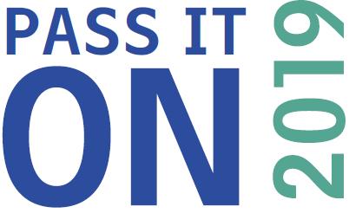
Halton ‘Pass it on’ 2019 Nomination Form
I nominate the following person or group as I think they meet the criteria for a good neighbour as described within the Pass it on briefing document.*
Person’s name:………………………………………………………………………………….
Group’s name:…………………………………………………………………………………...

Contact details of the person or group nominated:
Email:……………………………………………………………………………………………...
Telephone:………………………………………………………………………………………..
Address:…………………………………………………………………………………………..

For under 18 years:
School / College:………………………………………………………………………………...
Name of parent / carer or teacher:…………………………………………………………...

Age range(s) of the person or group I am nominating – please circle:
Please list your reasons for nominating this person, giving examples of what they do/have done which fit with the criteria of good neighbour-’Pass it on’ (see link below for further details). Photos etc can also be included with this nomination form (permission must be given before sharing). Continue on a separate sheet if necessary.

Under 11years 11-18 18 – 65 65years and over

My name:
………………………………………………………………………………………………………………………
My relationship with the nominated person (eg parent/carer, teacher, friend, neighbour, work colleague):
………………………………………………………………………………………………………………………
Name of organisation and my role/title within the organisation (if appropriate):
………………………………………………………………………………………………………………………
My contact details:
Email:………………………………………………………………………………………................................
Telephone:………………………………………………………………………………………………………..
Address:…………………………………………………………………………………………………………..
My signature: (electronic is acceptable)…………………………………………………………………….
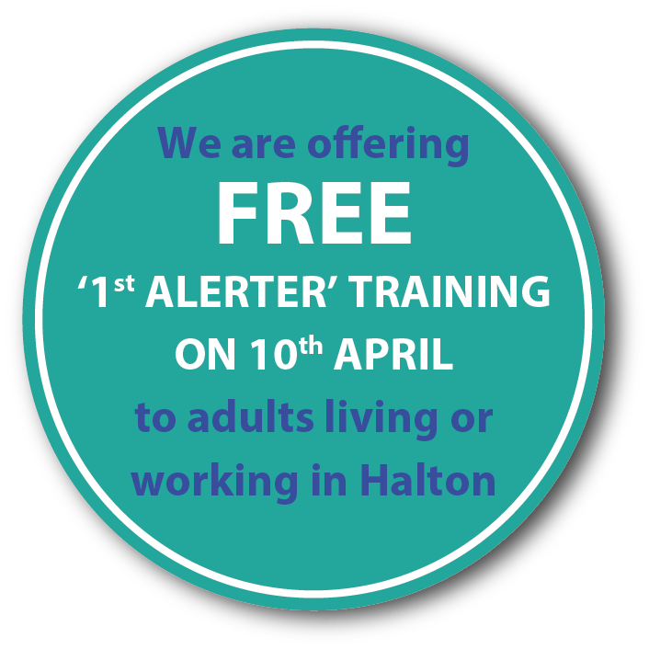Date:………………………………..

Please return this form to:
Email: marklunney@aukmm.org.uk
Or Post: Mark Lunney, CEO Age UK Mid-Mersey. The Mansion House, Victoria Park, City Road, St. Helens, WA10 2UE
Closing date for nominations:
31st May 2019 for schools’ and colleges’ nominations or
28th June 2019 for organisations’ and individuals’ nominations

The winners in each category will be selected by a judging panel. Winners will be notified before the awards ceremonies: which are on 3rd July for schools’ and colleges’ winners and 22nd July for all finalists. The overall winner will be announced at the Award Event on 22nd July.
*For more information visit the pass it on webpage HERE

Good Luck and Thank you

