hsab sTRATEGIC pLANNING EVENT The HSAB held a virtual Strategic Planning Event on Monday 2nd August 2021 via MS Teams, to develop priorities and key actions to inform the “Strategic Plan on a Page” and work programmes of the HSAB and its associated sub groups. The event was well attended with 30 representatives from all statutory partners, health sector and voluntary/third sector organisation as detailed below:

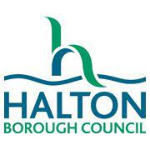
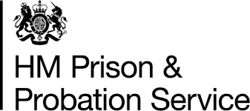
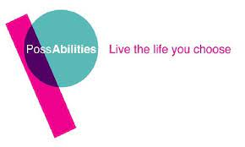
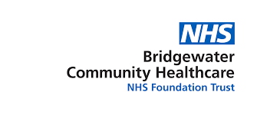
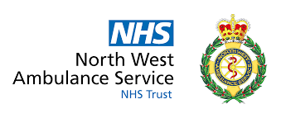
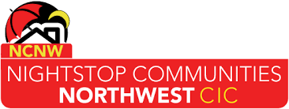
The event was facilitated by Claire Bruin, Care and Improvement Advisor East of England for the Local Government Association. The event began with an introduction and outline of the event that Claire presented, reminding partners of the legal context from the Care Act 2014, along with collective and individual responsibilities.

Helen Moir, Divisional Manager for Independent Living and Safeguarding Lead at Halton Borough Council, gave a presentation on the pre-work themes and what the data is telling us.

This lead to five breakout room discussions focused on the draft Strategic Plan; what other work areas should be added to the draft plan; what actions can organisations take to progress the proposed work areas and what support or guidance might sub groups provide to support member organisations. Each group had a one hour discussion, and then fed back to the whole group. From this multi-agency engagement event, a “Strategic Plan on a Page” has been formulated, based on the three main HSAB priorities of Quality Assurance; Learning & Professional Development and Co-production and Engagement.

NEXT STEPS
The Annual Report was presented to the Health Policy and Performance Board in September for approval and publication.

Information gathered from the Strategic Planning Event is being used by HSAB sub-group Chairpersons to support the development of the work programmes for the sub-groups into 2021/22 and beyond. Progress with the work programmes will be monitored through the HSAB Executive Group, who will update the HSAB as appropriate.

Due to the success of the Strategic Planning Event and the momentum achieved with engagement across the partner agencies, future planning sessions will be arranged.

